Lab #1: TTL Characteristics and SimUAid
In this lab, you will study TTL chip characteristics and how to model logic gates in software. This lab is to be done individually, and the report must be written in your own words.

Introduction: Why You Need Datasheets

Suppose you have an electrical component, and you do not know anything about it. You do not know what operation it performs, what electrical characteristics it has, or if the device is even analog or digital. Should you use it? The answer is obvious: no, you should not.

This logic applies to the transistor-transistor logic (TTL) chips in your lab kit. Even though they are easy to use, they have subtle physical requirements that must be satisfied, or else they will not function properly. It is important that you learn and understand these requirements before building a circuit. Many students do not appreciate this. They build their hardware labs imperfectly and deal with the consequences: hours of debugging.

Parts 1 and 2 of this lab help you find the characteristics of your TTL chips and use this information to rigorously design your circuit. Without subtle analog problems preventing your TTL chips from working properly, it is easier to focus on the digital logic design. Please review Lab 1 Part 2 every time you build a hardware lab!

Part 1: Getting Familiarized with the 74LS00 TTL Chip
For this part of the lab, you will research one specific chip from your lab kit: the 74LS00. Search online for the 74LS00 datasheet and explore it and find the function table, the pinout diagram, and see if you can discover the logic gate(s) that model this chip.
Questions: (Any figures must be labeled)

- What is DIP packaging? Include a figure containing an image of a 74LS00 chip in DIP packaging. Try to make sure the part number is visible! Hint: you have one in your lab kit.
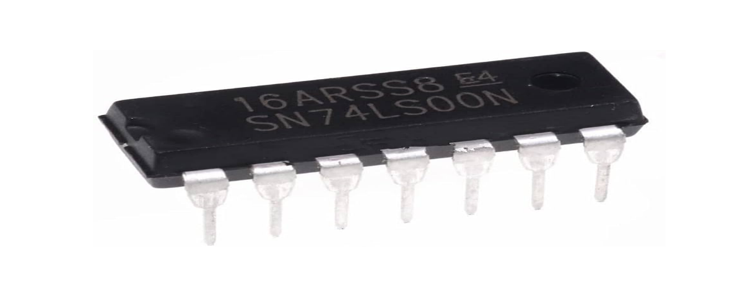
- There are five fields in the part number SN-74-LS-00-N. Explain what each field tells you about the chip. Applying this breakdown to the chip in your lab kit, how might this influence which datasheet you use, if you found more than one?
SN: Made by Texas Instruments
74: Transister-Transister Logic (TTL)
LS: Low power Schottky
00: Quad 2 input NAND gates
N: Dual Inline Package
Use a datasheet that matches LS and 00.
- Using the datasheet, how many total inputs and outputs are there in this TTL chip? How many inputs are used to generate each output? Include a figure of the pinout diagram.
8 inputs and 4 outputs 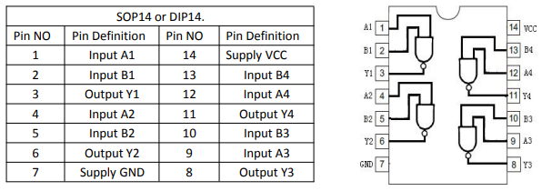
- Using the datasheet, what are pins 7 and 14 used for? What does the little notch in the plastic case do?
Pin 7 = Ground, Pin 14 = Vcc
- Provide a link to the datasheet you are using for this lab.

https://www.ti.com/lit/ds/symlink/sn74ls00.pdf

Part 2: TTL Characteristics of the 74LS00 TTL Chip
Using the datasheet, determine the values of the following voltage and current parameters:
Name: | Value or range: | Units:
VOH_min | 2.7 | V
VIH_min | 2 | V
VIL_max | 0.8 | V
VOL_max | 0.5 | V
VCC | 5 | V
IOL_max | 8 | mA
IOH_max | -0.4 | mA
IIL_max | 0.4 | mA
IIH_max | 20 | uA
These are all design parameters to keep in mind. If these characteristics and limits are known and followed, the 74LS00 chip will behave as promised. If not, undefined behavior may occur. Review the “TTL, Circuit Level Concepts” PDF file provided with the lab (and other resources if necessary) to answer the following questions.
Questions: (Formulas and calculations must be included)
6. Briefly summarize what each parameter above means.
VOH: Voltage Output High
VIH: Voltage Output High
VIL: Voltage Output Low
VOL: Voltage Output Low
Vcc: Supply Voltage
IOL: Current Output Low
IOH: Current Output High
IIL: Current Input Low
IIH: Current Input High

- What does positive logic and negative logic refer to?
Positive Logic: High Voltage = 1, Low Voltage = 0
Negative Logic: Low Voltage = 1, High Voltage = 0
- Explain what fan-in and fan-out mean. Determine the fan-in and calculate the fan-out of a single logic gate in the 74LS00 TTL chip. (Remember: fan-out needs to be calculated for both logical high and logical low outputs, just in case one is smaller). What should you do in your circuit to comply with fan-out?

Fan-in is the number of inputs a logic gate can take. Fan-out is the maximum number of output signals.

- Explain what pull-up and pull-down resistors are. What happens if you don’t put them when you use DIP switches as inputs to your TTL chips? (Hint: research “floating input voltage”).
Pull up resistor: A resistor connected between the input pin and Vcc
Pull down resistor: A resistor connected between the output pin and GND
If you don’t put these resistors an open switch can lead to unpredictable behavior.

- Calculate the maximum pull-up and pull-down resistances for a single logic gate input in the 74LS00 TTL chip using the specifications you put in the table above. Remember: if the resistances are too high, the pull-up/pull-down resistors don’t connect the input to ground or 5 [V] well, and you get invalid input voltage levels. Your objective is to find the largest resistance such that the input low voltage stays below V_{IL_max} (for pulldowns), and such that the input high voltage stays above V_{IH_min} (for pull-ups). The currents that pass through the inputs are on the table. Watch your units! Show your work and ask for clarification if you need it. After you’ve finished, explain in your own words why these limits are important.
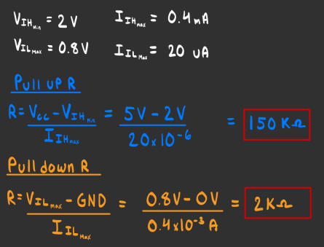
These limits are important because they are not within these limits the logic gate can react unpredictably.

- In practice, you will connect many logic gate inputs to one pull-up/pull-down resistor. Assuming the characteristics of the 74LS00 TTL chip, consider what happens if you connect n logic gate inputs to a single pull-up/pull-down resistor. Since having n gates multiplies the total current through the resistor by n times, briefly repeat the calculations from Question 10, but with n times the current. How do you modify your pull-up/pulldown resistor limit formulas to support n gates?
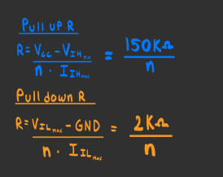
Tangent note: you have lots of resistors of value 1000Ω and higher in your kit, and comparatively few smaller than that. Since pull-up resistors tend to have a higher maximum resistance limit, it is often more convenient to use pull-ups instead of pull-downs (especially when connecting multiple inputs).
The other primary use for resistors is to protect your LEDs from burning up. DO NOT use resistors on your power and ground pins on your chips, or in between inputs and outputs between TTL chips because that will result in a buggy circuit.

Part 3: Software Implementation Using SimUAid

Using the logic function determined from the datasheet in Step 1, simulate the function of a single 74LS00 output in SimUAid with logic gate(s) and determine if the input combinations listed in the function table have the same output value in SimUAid. Note: The manual for SimUAid is in the folder of Lab 1.

If you do not wish to use SimUAid, LTspice is a very popular simulator for both Mac and Windows. There are plenty of YouTube tutorials to guide you.

The following segment is an example analysis. You should emulate this with the logical operation performed by the 74LS00 chip. Avoid copying this analysis by accident.

An example of what is expected from your software design:
We have built two circuits representing the NOR gate. Shown below in Figure 1, we have implemented the same logic function twice. The top circuit with output F1, is an OR followed by a NOT. Or we can call this the NOR gate, of which is the bottom second circuit with the F2 output.

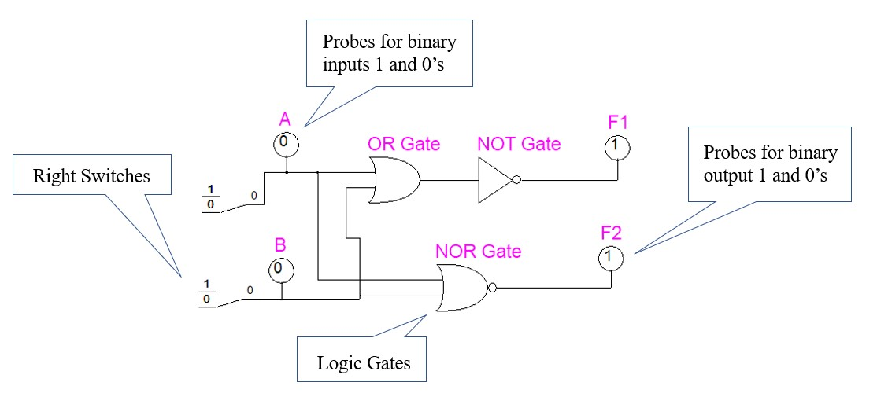

Figure 1: SimUAid NOR Circuit Build
Figure 1 shows right switches, binary probes and logic gates. All of these can be found in the Parts tab at the top of the SimUAid window. This logic circuit diagram shows a positive logic flow. Representing bit 1 as a HIGH and bit 0 as a LOW. Both the top and bottom circuits have inputs A and B. And since they both represent the same logic function. Then that will mean for all A and B combinations. F1 will always be equal to F2. As seen on the function table below:

Table 1: Truth Table for the NOR Gate
In | puts | Output
A | B | F
0 | 0 | 1
0 | 1 | 0
1 | 0 | 0
1 | 1 | 0

We can then see that Figure 1 shows the A and B combination 00 produces the output of 1.

This concludes the example analysis.

Task:
Build the logic circuit of the 74LS00 in SimUAid or LTspice and perform the same analysis from the example.

If the 74LS00 is a combination AND, OR, or NOT gates, we expect you to build two circuits that are equivalent to each other, and that both use the same combination of inputs. Show that your input and output values match the ones in the datasheet. Make sure you label your inputs, your logic gate(s), and your output(s). Make sure to label your figures and tables accordingly.

Part 4: Submission Deliverables
Turn in your report in either PDF or Word format, and make sure it is named: ECE3441_StudentID#_Lab1.

Use the following structure for your lab report:

ECE 3441– Summer 25
Lab 1 R
Angel Chaverria
Overview: Goals of the Lab
The goal of this lab was to teach students how to read data sheets, how to find the pull up/down resistance, and to get familiar with SimUAid. To read a data sheet you have to make sure you are looking at that matches with LS and 00. Find the pull up/down resistance involves simple ohms law. Students are also using SimUAid to build the 74LS00.
Step-by-Step Procedures and Results
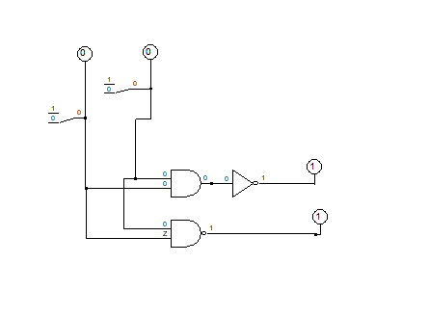
Conclusion
In this lab I learned how to read a data sheet from a 74LS00. I also learned various terms like VOH, VIH, VIL, fan out/in, pull up/down resistors. I also learned how to use simuaid.

